Tick-Borne Disease Knowledge Assessment (Pre-Assessment)

Matching:

1. Tick A. Lone Star Tick

2. Pathogen B. Organism that a parasite feeds on

3. Vector C. Type of Arachnid

4. Host D. Feeds on the outside of an organism

5. Ectoparasite E. American Dog Tick

6. Endoparasite F. Passes a disease from one organism to another

7. Zoonosis G. Black-legged (Deer) Tick

8. Sentinel H. Normally found in or native to an area

9. Endemic I. Disease-causing organism

J. Disease transmitted to humans from animals

K. Feeds on the inside of an organism

L. Provides a guard or warning for others

M. Brown Dog Tick

10. 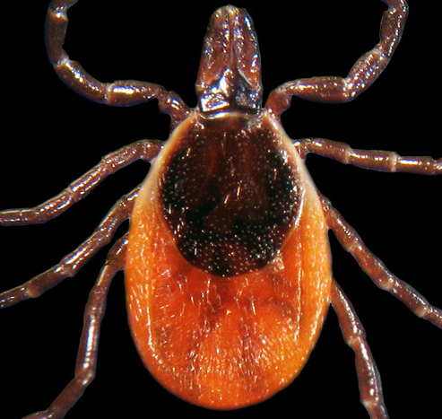

11. 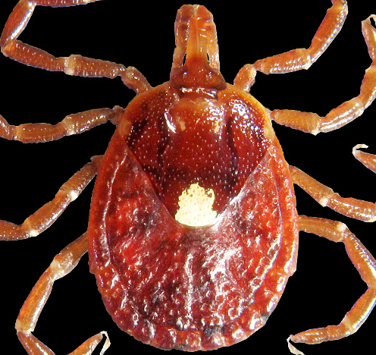

12. 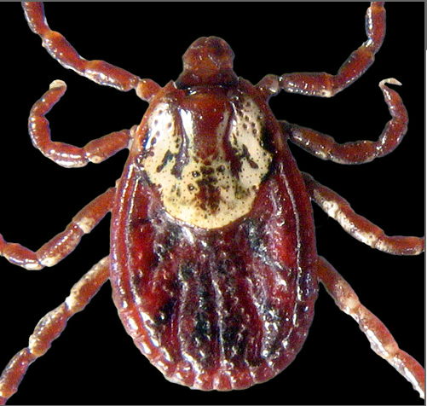

Multiple Choice:

13. What are life stages for a tick?
A) egg, worm, adult
B) egg, nymph, adult
C) egg, larva, nymph, adult
D) egg, worm, larva, adult

14. How long does their life cycle take?
- 10 years
- 6 months
- 10-12 months
- 2-3 years

15. How do ticks find their hosts?
- see them coming and jump onto host
- sense heat or vibration and climb onto a host that brushes by them
- climb up trees and fall onto hosts walking under
- fly around looking for hosts to attack

16. Most tick-borne diseases are what type of pathogen?
- bacteria
- virus
- protozoa
- fungus

17. What are typical symptoms of tick-borne disease?
- fever, welt where bite is located, rash
- fever, headache and muscle aches, sometimes rash
- joint pain, rash, open ulcers on skin
- anemia, paralysis, rash

18. How do doctors diagnose a tick-borne disease?
- Blood samples (look for pathogen)
- PCR (look for pathogen DNA)
- IFA, Western-Blot, ELISA (look for antibodies)
- All of the above

19. What should you do to prevent tick-bites?
- never go outside
- stay out of long grass, wear long pants and use DEET
- don’t have a dog or cat
- don’t climb trees or travel

20. What is causing the increase in tick-borne diseases?

- increase in number of deer in the US
- ticks are mutating to carry more disease
- more people have pets (dogs and cats)
- all of the above

